|  |  |
| --- | --- |
| BNC oPT-OUT MANAGEMENT  CAMPUS GUIDE |  |

Contents

Introduction 2

Opt-Out Window Start & End Dates 2

Opt-Out Start and End Date 2

Opt-Out/Opt-In Action Email Communications 2

Opt-Out Confirmation Email 3

Course Materials Access After Opt-Out Email 4

Opt-In Confirmation Email 5

Student Experience 6

SSO Login 6

Opt-Out Page 6

Opt-In Page 8

Rules for Handling Enrollment Data 9

Data Shared with School 10

Naming Convention 10

Folder Structure 10

Data Layout 11

Error Handling 12

Error at Student Login 12

Error on Student Action: OPT-OUT 13

Error on Student Action: OPT-IN 14

# 

# Introduction

The opt-out management feature allows Barnes & Noble College (BNC) to manage student participation status and be the single source of truth for students who choose to opt-out of the First Day 2.0 (FD2.0) program.

Students will have a separate experience apart from the FD2.0 student portal where they can opt-out or opt back into the program, generally accessed from the program landing page hosted on the campus website.

The following are requirements and specifications for BNC Opt-Out Management.

# Opt-Out Window Start & End Dates

## Opt-Out Start and End Date

* Students are only able to opt-out or back into the FD2.0 program during the opt-out period.
* The start and end dates will be set to the following defaults:
  + Default Opt-Out Start Date will be set as 14 days before the term start date
  + Default Opt-Out End Date will be set as 21 days after the term start date
* The Store Manager can reconfigure these dates in AIP for each term where opt-out is enabled.
* The opt-out period can be set to as early as 30 days before term start date

# Opt-Out/Opt-In Action Email Communications

Based on the **action taken by the student** to opt-out or opt-in, they will receive the following email communications:

* Opt-Out Confirmation
* Course Materials Access After Opt-Out Decision
* Opt-In Confirmation

## Opt-Out Confirmation Email

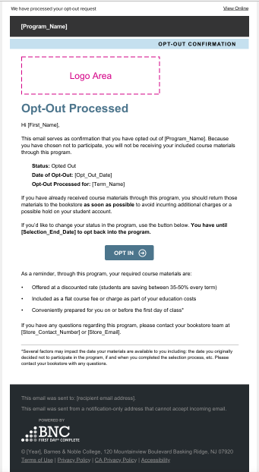

The opt-out confirmation email will be sent immediately to the student who chooses to opt-out of the FD2.0 program after they opt-out using the feature.

The email confirms the student decision to opt out and provides a link to opt back in. This email is sent only once per opt-out action.

## Course Materials Access After Opt-Out Email

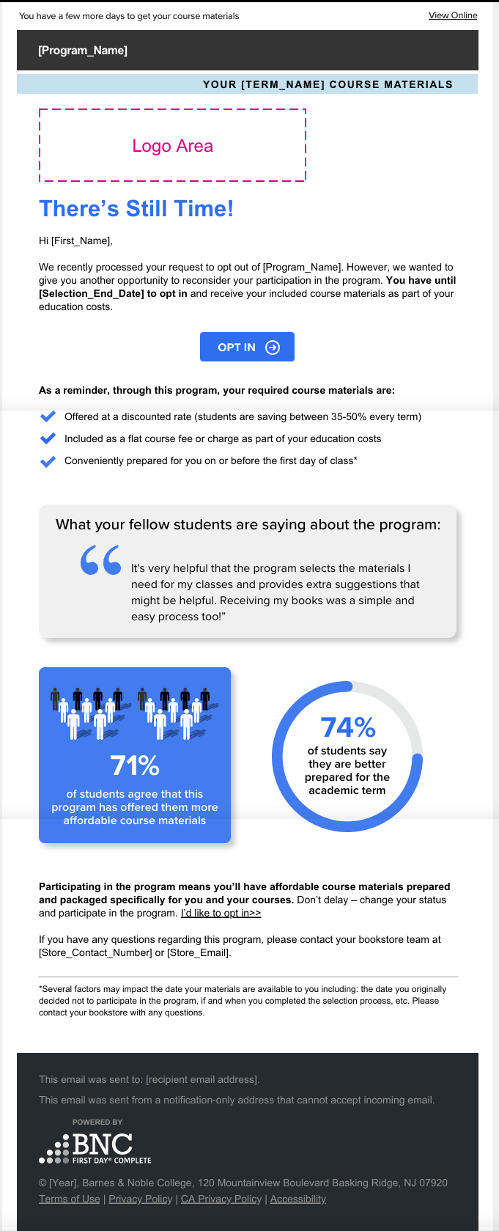

Three days after opting-out, students will receive an email with options for obtaining course materials after deciding to opt-out. This email informs the student that they are opted out and provides links to both opt back in or to buy their materials directly through the bookstore website.

This email is sent only once. A student who opts out will not receive it again unless they opt-in and then opt back out a subsequent time.

## Opt-In Confirmation Email

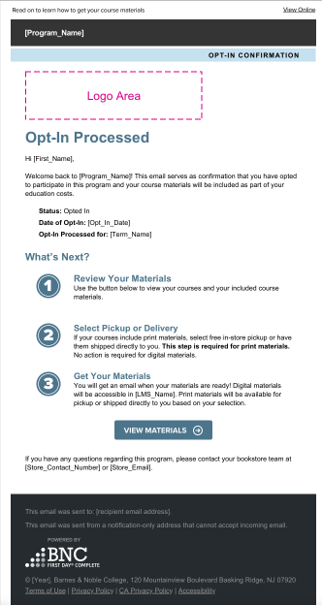

The opt-in confirmation email is sent to the student who chooses to opt back into the First Day 2.0 program immediately after they opt back in using the BNC tool.

The email confirms the student choice to opt-in and provides a link to view course materials in the FD2.0 portal. This email is sent only once per event. A student who opts back in will not receive another confirmation email unless they opt-out and opt back in again.

# Student Experience

## SSO Login

Opt-Out SSO Link Web Placement

* These instructions should be provided to your web portal administrator.
* The opt-out SSO link will be supplied by your BNC implementation team and should be placed on your program landing page / program FAQs.
* BNC recommends placing this link under the FAQ regarding “Can I opt out” and/or “Can I opt back in?”

## Opt-Out Page

* Once the ‘eligible’ student user successfully logs in via the SSO, the system will redirect the user to the opt-out page, where they can take two actions: **VIEW MATERIALS** or **OPT OUT**

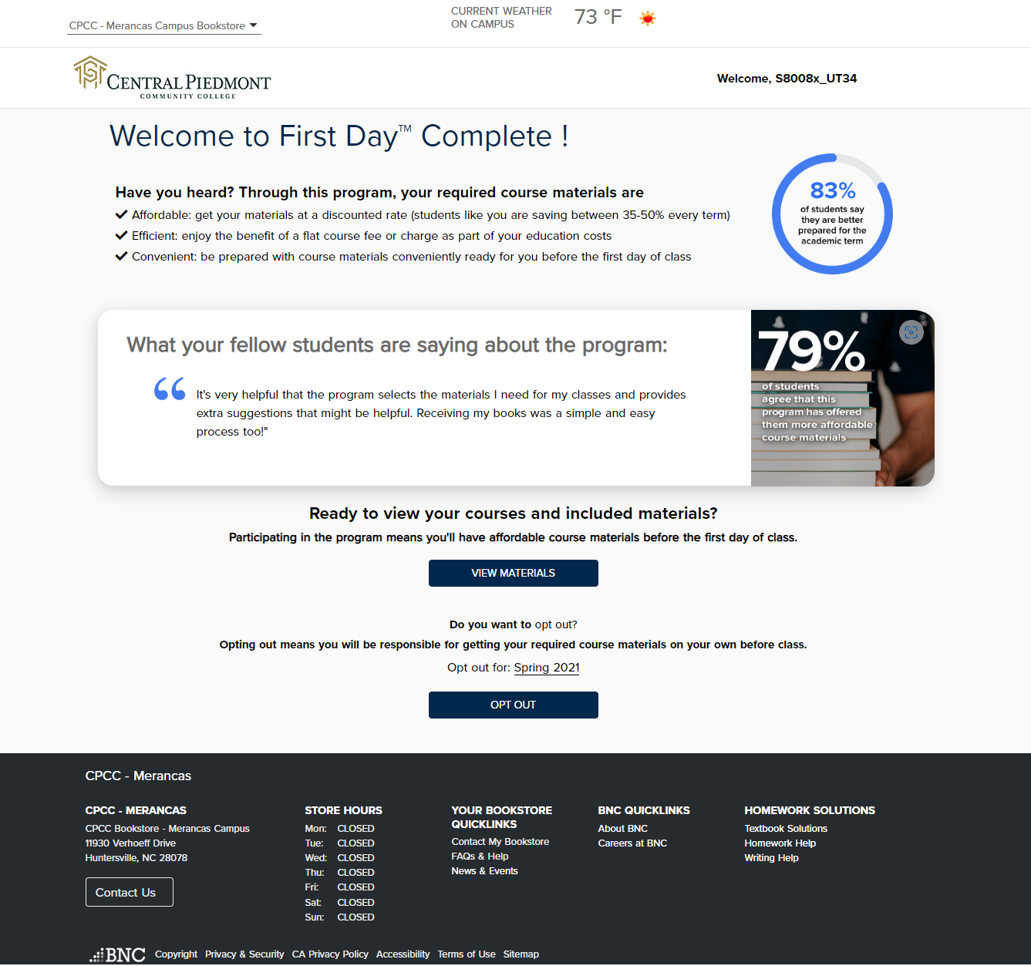

VIEW MATERIALS

* If a student user clicks on this button, the system will redirect the student user to the FD2.0 Student Portal.
* The student will be able to view the course materials for all their included FD2.0 courses.

OPT-OUT

* When a student user clicks on this link, the system will check that the current date is within the Opt-Out window.
* If it is within the Opt-Out window, the system will display a pop-up with information about the advantages in continuing with the FD2.0 program.

There are two possible pop-ups designed for students based on the books associated with their courses:

* + **Cost Savings pop-up**

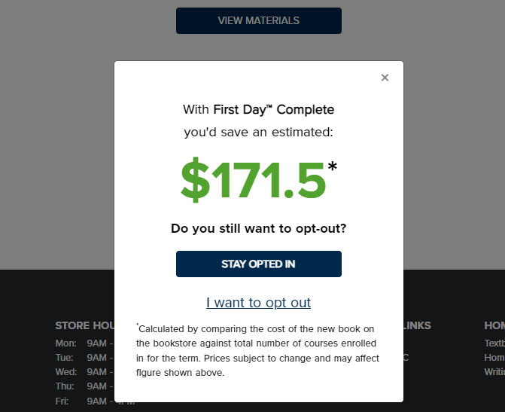

* + **Time Saving pop-up**

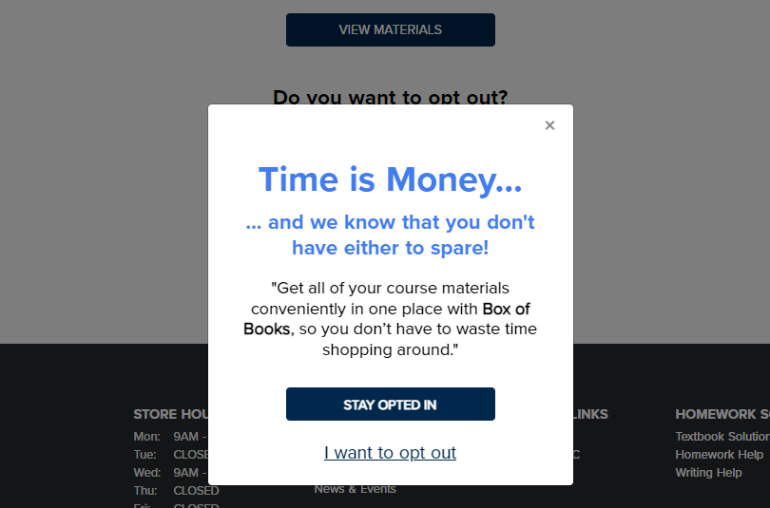

* If the student selects **STAY OPTED IN** they will be redirected to their personalized course materials page to make their selection on how they would like to receive their materials.
* If the student selects **I want to opt out** they will be directed to the Opt Out confirmation page and they will be considered as Opted out for the Selected term

## Opt-In Page

* A student user, who has previously opted out for an enabled term, will be redirected to the opt-in page upon logging in via the opt-out SSO link and take one action: **OPT IN**

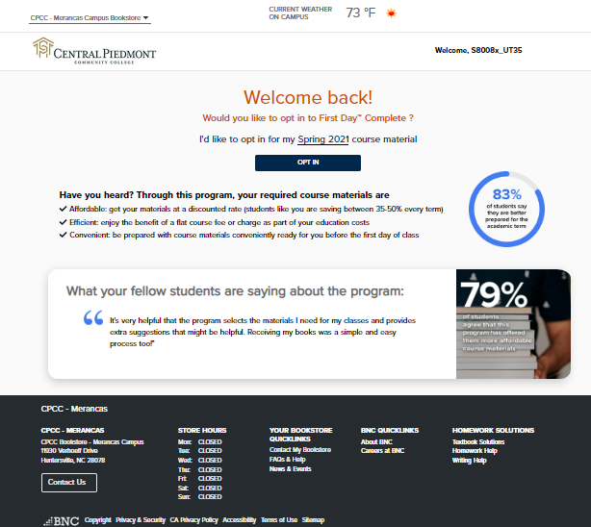

OPT-IN

* When a student user clicks on this link, the system will check that the current date is within the Opt-Out window.
* After selecting opt-in, the student will be redirected to their personalized course material page to make their selection on how they would like to receive their course materials.